Discover the richness of Tunisian heritage with our exclusive tour focused on UNESCO World Heritage sites
And of course, don't miss tasting the delicious Tunisian gastronomy, traditional dishes such as: couscous, briks, spicy harissa sauce and the sweet treats of Tunisian oriental pastries, fruits of course dates and without forgetting of course the oil.
This tour promises a unique experience combining the culture, history and exquisite flavors of Tunisia.
Be ready to embark on this unforgettable adventure.
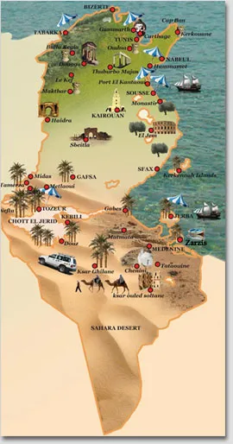

DAY 1 :
- Reception at Tunis Carthage airport
- Reception by the guide and installation at the hotel in Tunis
- Dinner and Hotel

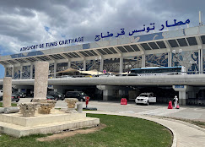
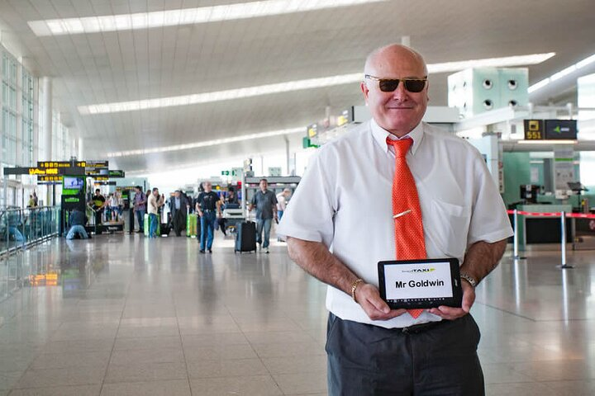

DAY 2 :
- Breakfast at the hotel
- Visit Carthage (by bike or electric scooter): world heritage 1979
- Visit Tunis The Medina: world heritage 1979
- Passage for a Tunisian cooking class in Dar Slah
- Lunch at Dar Slah: couscous menu (intangible culinary heritage 2020)
- Dinner and night in Tunis

The archaeological site of Carthage is made up of numerous remains distributed within a vast residential area, plunging into the Mediterranean. It was listed as a UNESCO World Heritage Site in 1979.
While strolling by bike and in the company of our professional guide, discover the site of Carthage, it is an immense garden which will gradually reveal these hidden treasures to you.
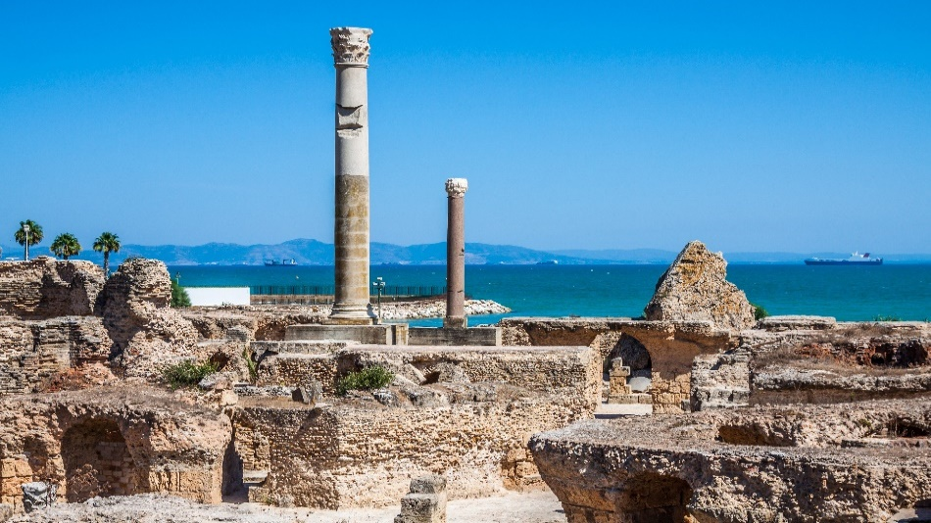
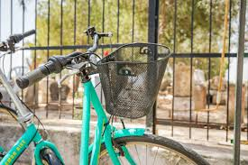

Imagine learning the secrets of authentic Tunisian cuisine straight from the source. The course at Dar Slah will allow you to discover traditional ingredients, preparation techniques and tips for obtaining delicious couscous. You participate in each step and get your hands dirty. And of course, you will be able to taste your culinary masterpieces at the end of the course. It’s an interactive and gourmet experience that will allow you to bring a little bit of Tunisia home.
Were you ready to become a Tunisian couscous pro?
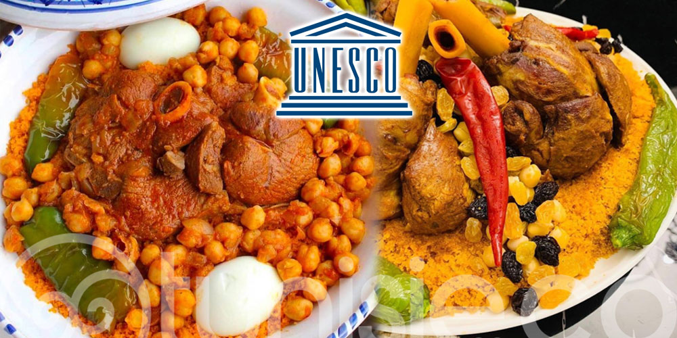
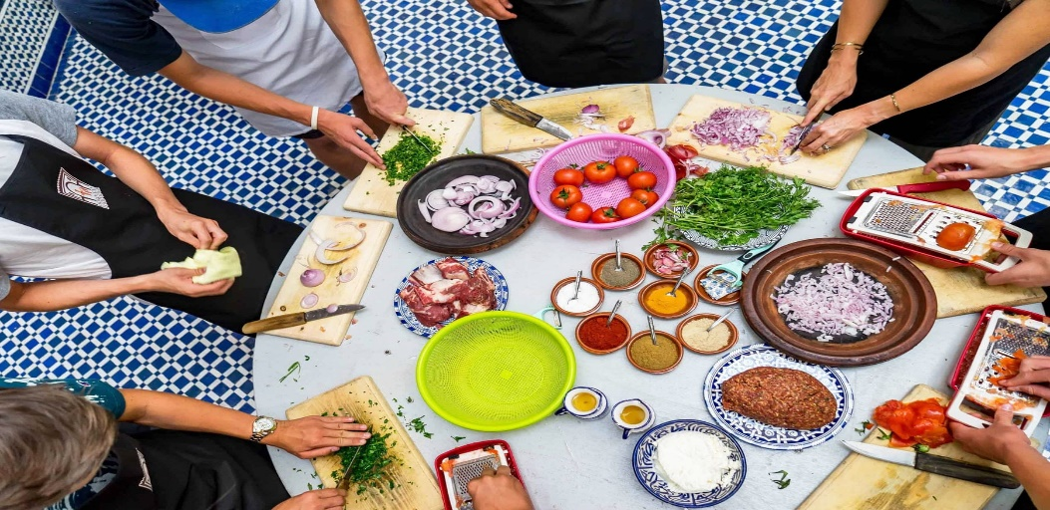

The medina of Tunis is listed as a UNESCO world heritage site, it is a true historical gem. As you stroll through its narrow streets, you will be transported to another time, surrounded by magnificent ancient buildings and superb carved wooden doors. The souks of the medina are full of treasures, from colorful spices to ceramics and traditional jewelry. It is a true paradise for shopping and culture lovers. Prepare yourself for a captivating adventure in this exceptional historic place!
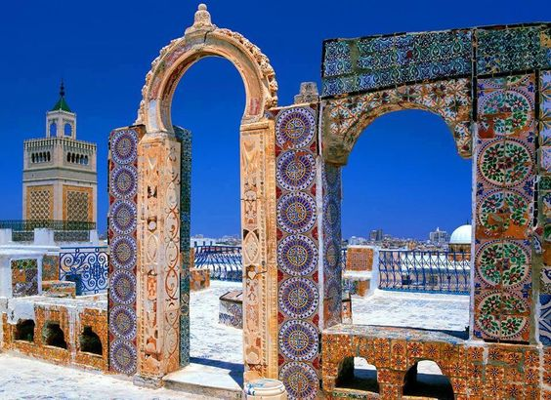
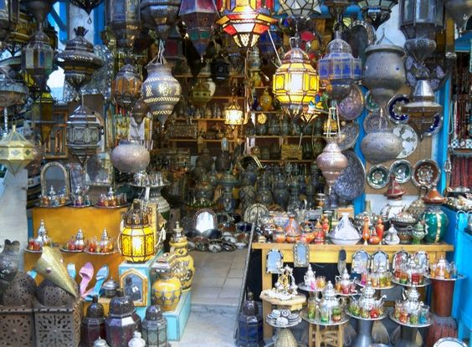
DAY 3 :
- Breakfast at the hotel
- Departure to Mornag: Wine tasting
- Continue to Zaghouan
- Lunch at the Dar Zaghouan guest house
- Hike or zip line in the Zaghouan mountain with Zaghouan adventure (extra)
- Accommodation in Hammamet: Dinner and night at the hotel

Mornag is renowned for its vineyards and delicious wines. During the tour and tasting, you will be able to discover the different grape varieties grown in the region by learning more about the winemaking process and of course taste a selection of local wines. You can also walk between the rows of vines, breathe in the aroma of ripe grapes and savor wines with unique flavors. This is a perfect opportunity to learn more about Tunisian wine culture and expand your wine knowledge. Don't forget to take a few bottles as souvenirs to extend this experience at home. Cheers!

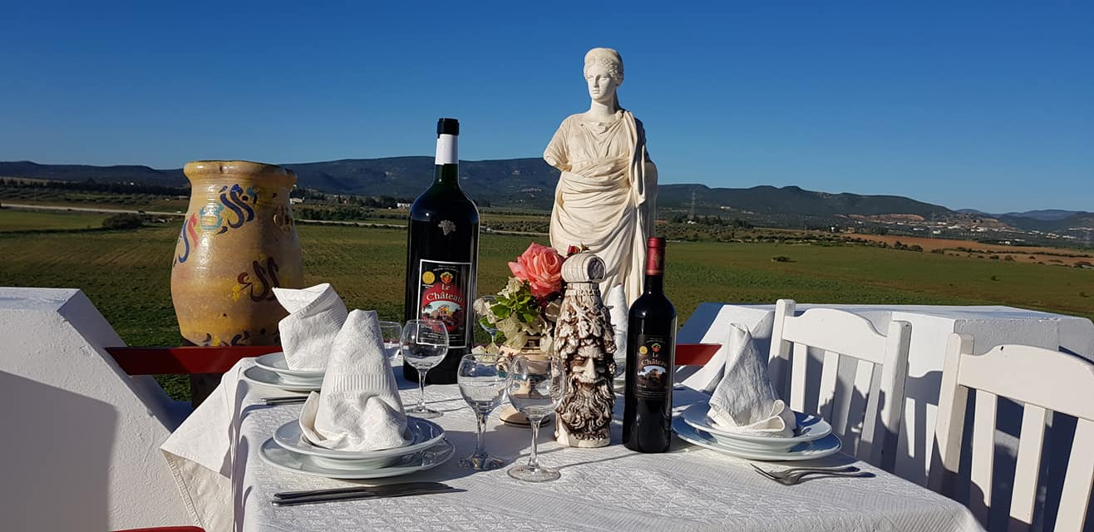
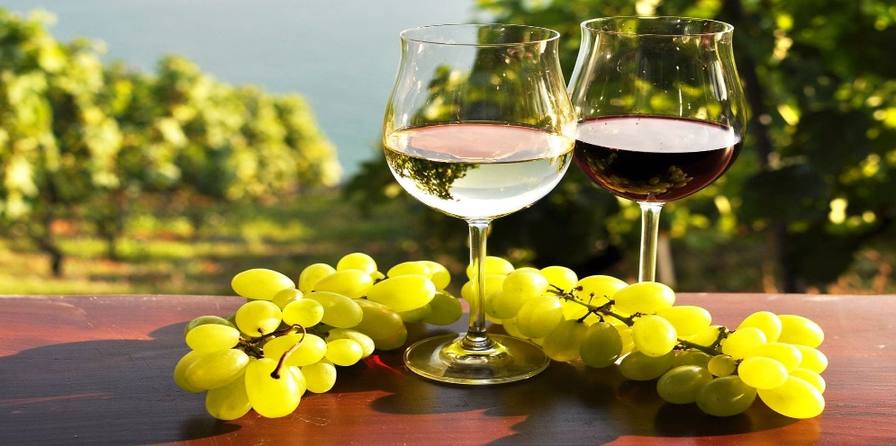

Dar Zaghouan is a beautiful place to enjoy traditional Tunisian cuisine and festive atmosphere. In a picturesque setting surrounded by greenery, it is the perfect opportunity to discover the culture of the region in all its splendor, enjoying delicious dishes and dancing to the sound of folk music. Enjoy this unique moment and don't forget to share photos and videos.

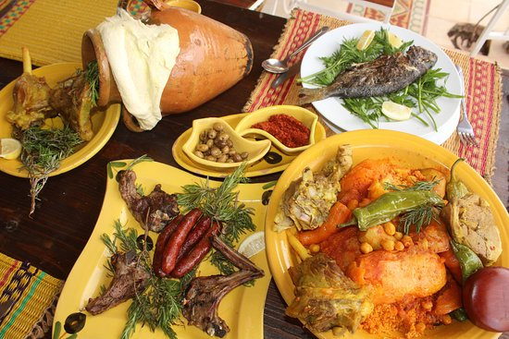
After this delicious lunch in Dar Zaghouan, opt for sporting activities such as ziplining and hiking in the Zaghouan mountains with Zaghouan adventure. The scenery is absolutely stunning and the area is full of scenic trails to explore. You can stroll through the green hills, breathe the fresh mountain air and enjoy breathtaking panoramic views. This hike will be a memorable experience and a beautiful way to connect with nature. So, put on your sneakers and get ready for an unforgettable adventure!
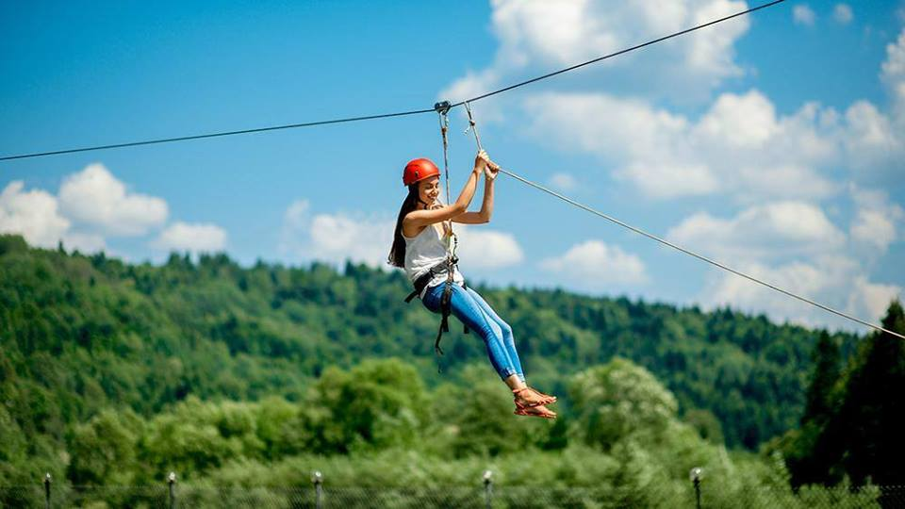

DAY 4 :
- Breakfast at the hotel
- Bike ride in Douar Laaroussi (extra)
- Typical lunch in Douar Laaroussi
- Visit Dar la Harissa to Nabeul: Hedgehog preparation workshops (world heritage 2022)
- Accommodation in Hammamet: Dinner and night at the hotel

Opt for a sporty mountain bike adventure through the region's magnificent mountainous landscapes. In Douar Laaroussi and after this mountain bike escapade, along winding paths, surrounded by wild nature and breathtaking views, treat yourself to a typical lunch and traditional dishes and discover the authentic flavors of the region.
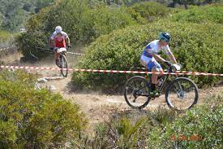
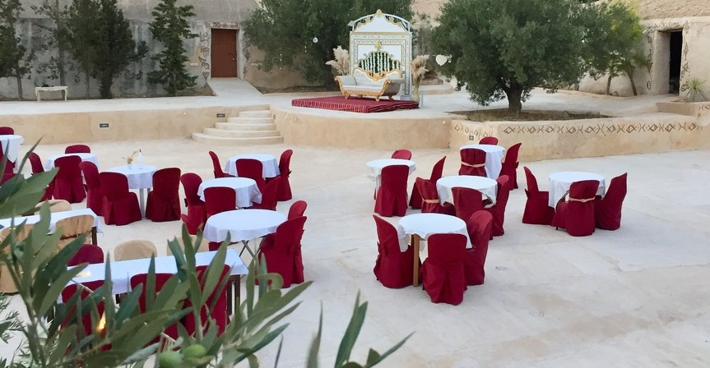

Dar la Harissa is an iconic place where you can discover the history and tradition of making this delicious spicy sauce. During the workshop, you learn the secrets of preparing harissa, mix the ingredients and create your own personalized recipes and add a touch of spice to your favorite dishes. It’s a unique experience that will allow you to immerse yourself in the culinary culture of the region.
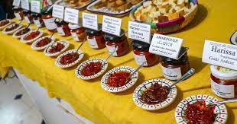
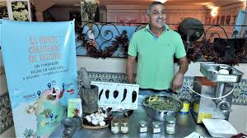
DAY 5 :
- Breakfast at the hotel
- Visit the Sousse medina: world heritage 1988)
- Lunch in Sousse
- Visit El Jem: world heritage 1979
- Accommodation and dinner in Sfax
The medina of Sousse is a true historical treasure, with its narrow streets, traditional houses and magnificent carved wooden doors. You'll be transported back in time as you explore the bustling souks, where you'll find local artisan goods such as pottery and jewelry. The Great Mosque, with its impressive architecture, or the Ribat, a medieval fortress offering panoramic views of the medina and the sea. It is an unforgettable experience that will allow you to discover the history, culture and architecture of this magnificent city.
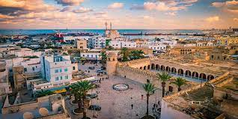
The visit to the El Jem amphitheater, which has been a world heritage site since 1979, is simply incredible! This amphitheater is one of the largest and best preserved in the world. You will be amazed as you contemplate its impressive architecture, its majestic arcades and its stands which could accommodate up to 35,000 spectators at the time.
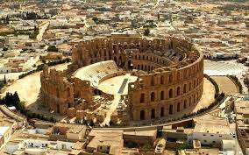
DAY 6 :
- Breakfast at the Fekih cottage
- Panoramic tour of Sfax
- Departure to Djerba
- Lunch in Djerba
- Visit Djerba Hood
- Assistance at sunset on the island
- Accommodation in Djerba: Dinner and night at the hotel

Sfax, This fascinating city is known for its fortified medina, surrounded by imposing ramparts. As you stroll through its narrow streets, you will discover magnificent traditional houses, historic mosques and lively souks where you will find local artisan products. Sfax is also famous for its fishing and olive oil industry, so be sure to sample some EXTRA VIRGIN oil.

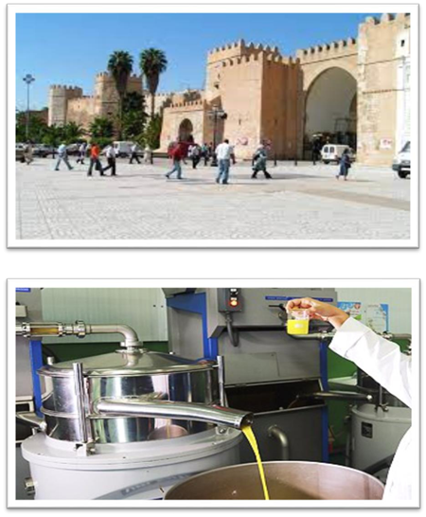

Djerba Hood is an international street art festival that takes place on the island of Djerba in Tunisia. During the festival, artists from all over the world come to beautify the city walls with their colorful and creative works. It's really impressive to see how the streets are transformed into open-air art galleries. As you stroll through the alleys, you can discover stunning murals, unique art installations and a vibrant ambiance. It is a great place for art lovers.

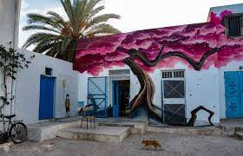
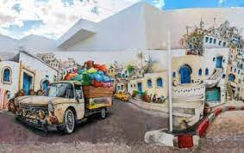

DAY 7 :
- Breakfast at the hotel
- Visit Houmet Souk
- Visit the Ghriba Synagogue
- Lunch based on seafood and fish
- Visit Guellala: the heritage museum and pottery workshops
- Accommodation in Djerba: Dinner and night at the hotel

Houmet Souk and Harra Sghira in Djerba; These two sites have been part of World Heritage since 2023, making them essential places to explore. Houmet Souk is the main town on the island of Djerba and is known for its traditional architecture and picturesque streets. You can stroll through the lively souks, discover artisanal shops and taste delicious local specialties. As for Hara Sghira you can enjoy the tranquility of this preserved place and meet the ancient Djerbian Jews and of course explore their traditions.

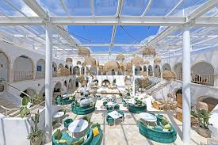

The Ghriba Synagogue is one of the oldest synagogues in the world, and is a holy place for the majority of the Jewish community. During your visit, you will be amazed by its unique architecture and magnificent mosaics. Ghriba is also known for its annual pilgrimage, where thousands of people gather to celebrate and pray. It is a place full of history and spirituality.
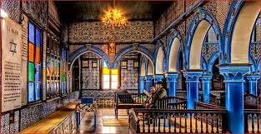
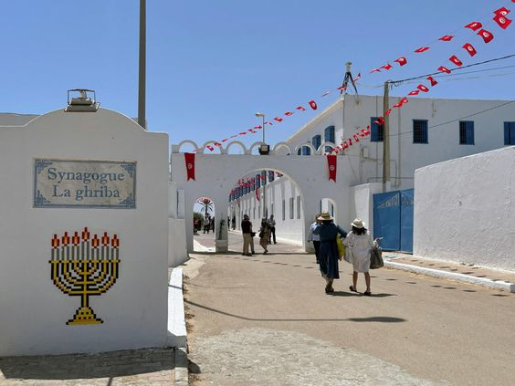
The Guellala heritage museum in Djerba, this museum is dedicated to the art of traditional crafts of the island. The exhibits reflect the history and culture of Djerba and will allow you to delve into the traditional crafts of the region. It's a great place to learn about the art and history of Djerba.

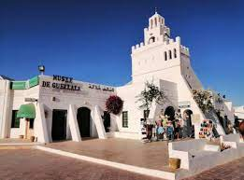
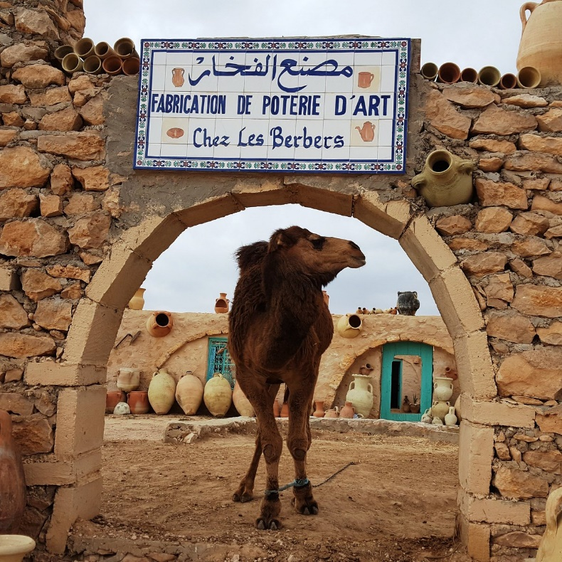

DAY 8 :
- Breakfast at the hotel
- Departure to Tataouine
- Visit: The sleeping septs, ksar Ouled Mhamed, ksar Zahra, ksar Ouled Soltane
- Lunch in Cheneni
- Trek to Douiret
- Accommodation at the troglodyte lodge: Dinner and night at the lodge

THE SEVEN SLEEPERS:
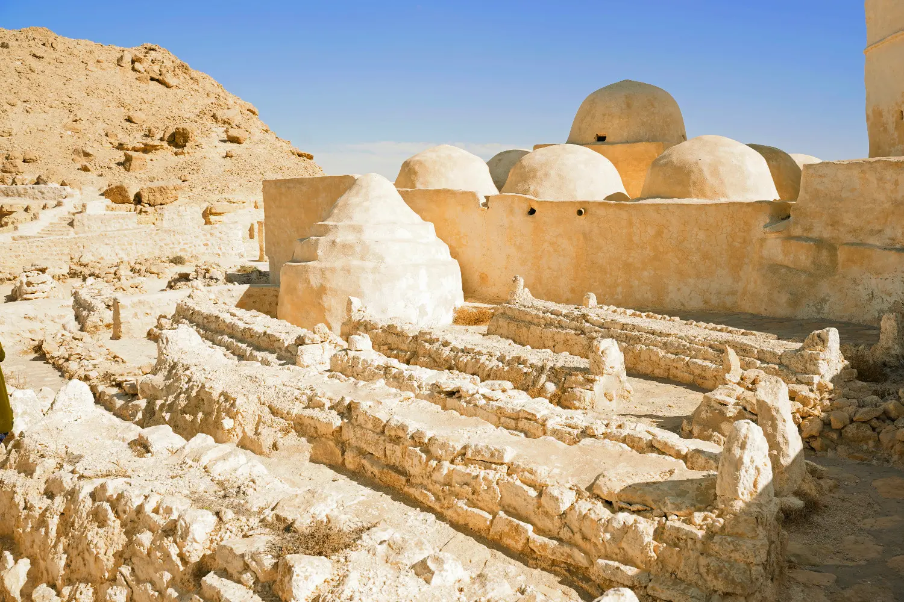
KSAR OULED SOLTANE : 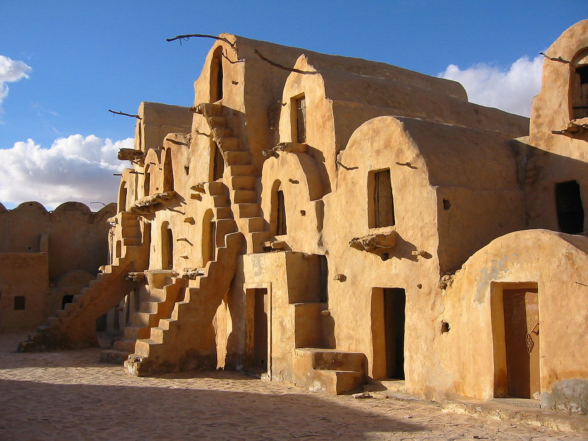

KSAR OULED MHAMED :
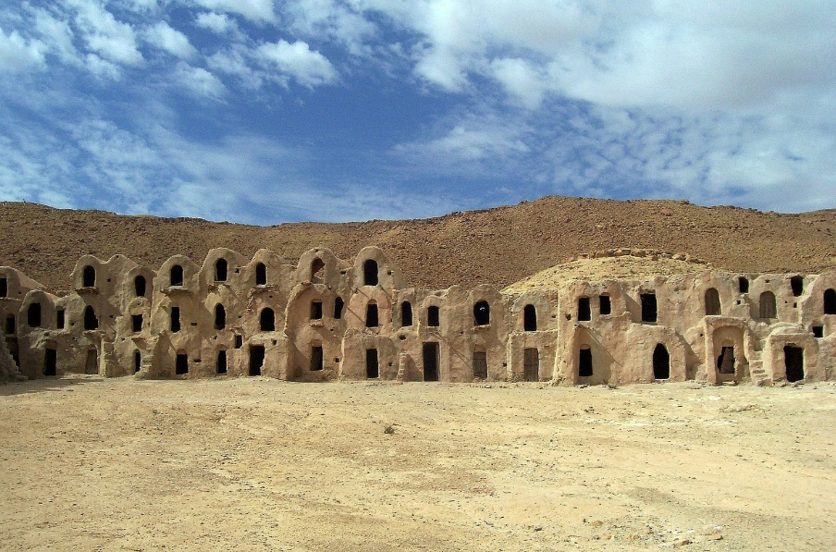
KSAR ZAHRA :
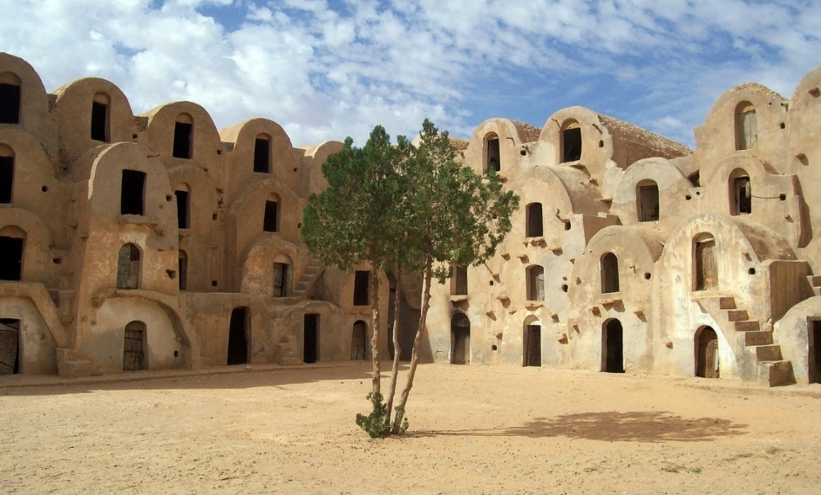
Trek from CHENINI to DOUIRET :
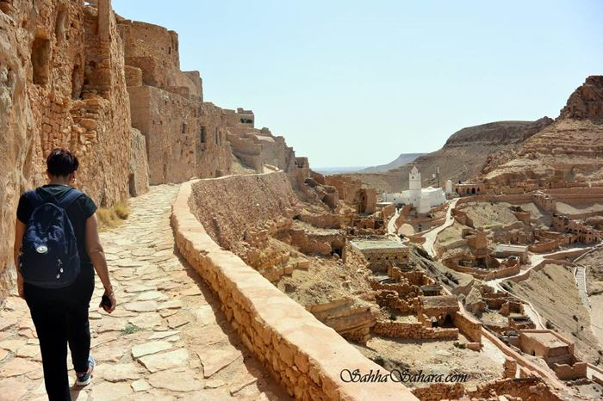

LODGE DOUIRET :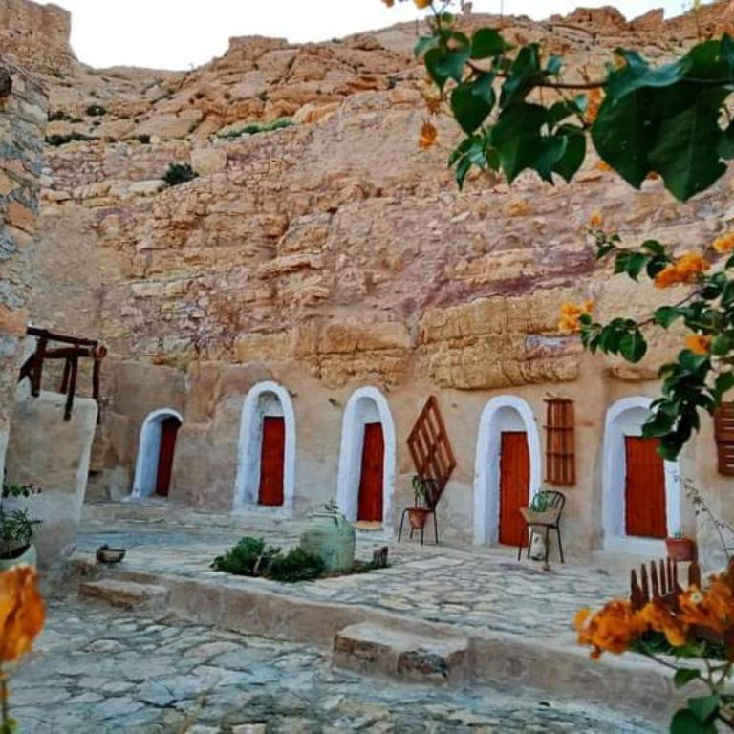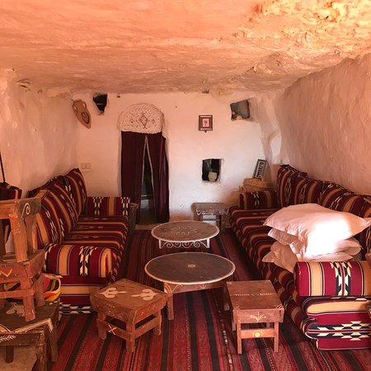
DAY 9 :
- Breakfast at the lodge
- Lunch in Douiret
- Departure in 4*4 to the oasis of Ksar Guilaine
- Visit to the oases: Bathing in the hot water spring
- Night in tents at Zmela camp
Lunch Douiret :
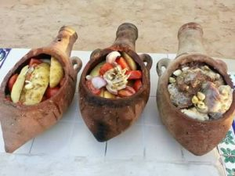
KSAR GHILANE AND THE HOT WATER SRING:
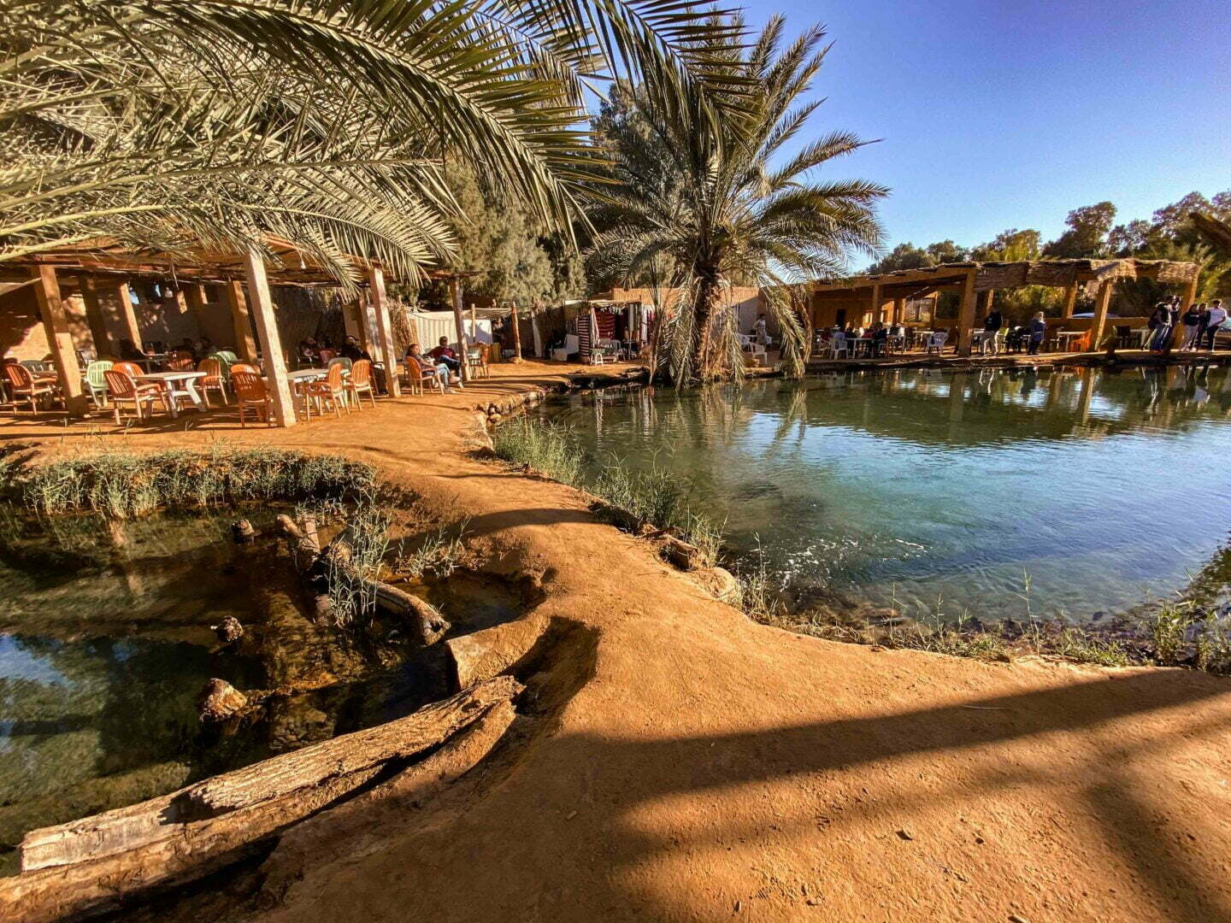

CAMP ZMELA :
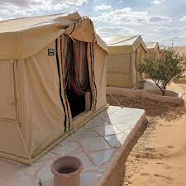

The Khobz El Mella preparation workshop at the Saharan camp; you will have the opportunity to discover the secrets of preparing this delicious traditional Tunisian bread. The workshop takes place in an authentic setting in the heart of the desert, where you learn traditional MELLA bread kneading techniques; it’s southern bread baked in the sand in the middle of the embers. You will be accompanied by local experts who will share with you their know-how and their love of SAHARA
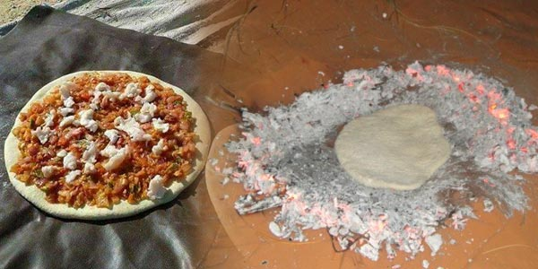
DAY 10 :
- Breakfast at the camp
- Departure towards Douz via the sand dunes
- Visit the town of Douz
- Lunch in the oasis
- Visit Chot Jerid
- Continue to Tozeur
- Visit to Eden Palm Park (world heritage 2022)
- Accommodation in Tozeur : Dinner and night at the hotel
- Night visit to the medina of Tozeur
DOUZ :
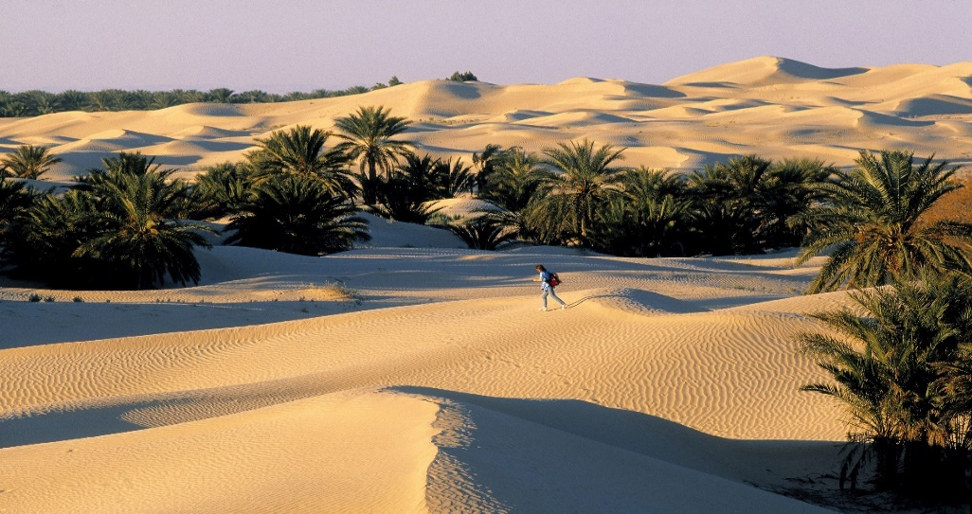
CHOT JERID :
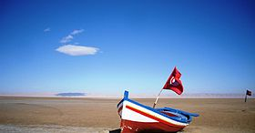
Eden Palm in Tozeur This magnificent place highlights the knowledge, know-how and practices associated with date palms, which have been part of Tunisia's world heritage since 2022. During your visit, you will discover the importance of this giant plant emblematic of Tunisian culture, as well as the different stages of date production. You will walk through the palm groves and admire the picturesque landscapes.
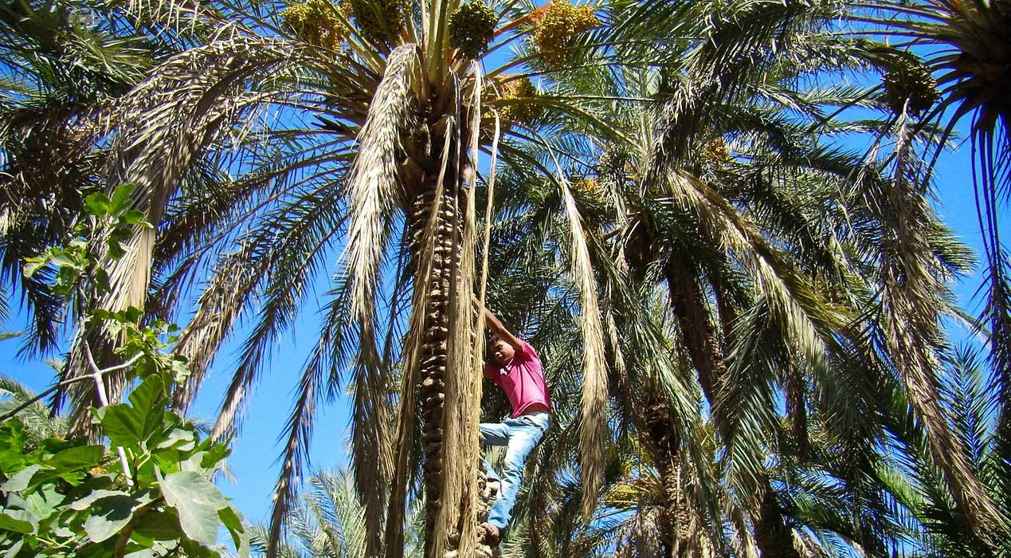
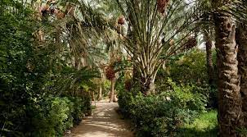

TOZEUR BY NIGHT
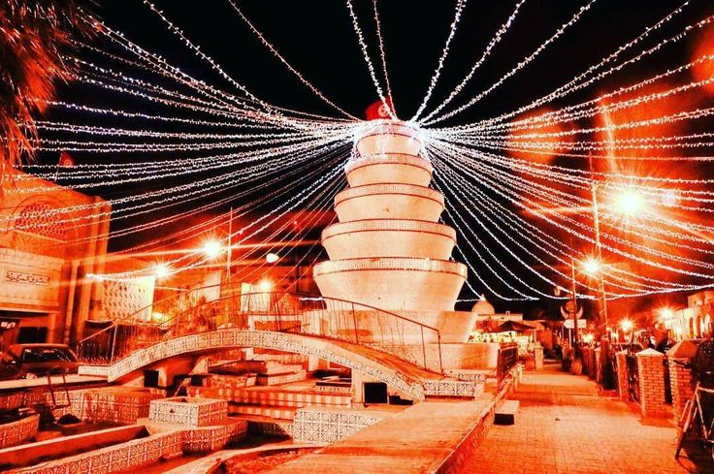

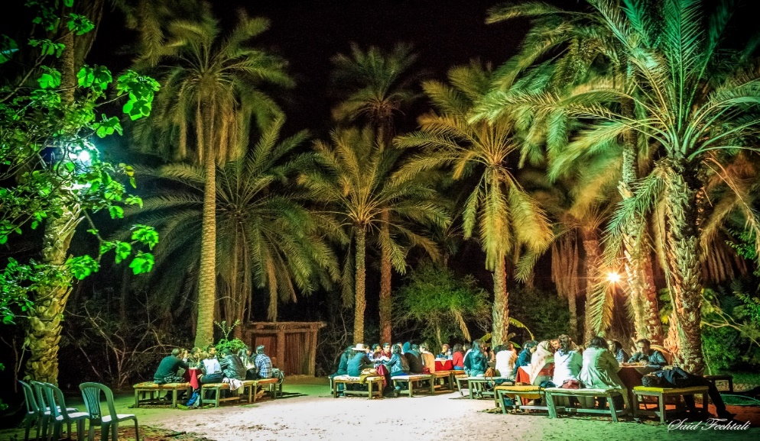

DAY 11 :
- Breakfast at the hotel
- Visit the Chebika oasis
- Visit the Mides canyons
- Visit the Tamaghza waterfalls
- Lunch at Diari Tamerza
- Star Wars site visit
- Visit to the Nafta basket at sunset time
- Opportunity to attend a typical dinner and evening in Douar Hafsi
-Night at the hotel

THE OASIS OF CHEBIKA :
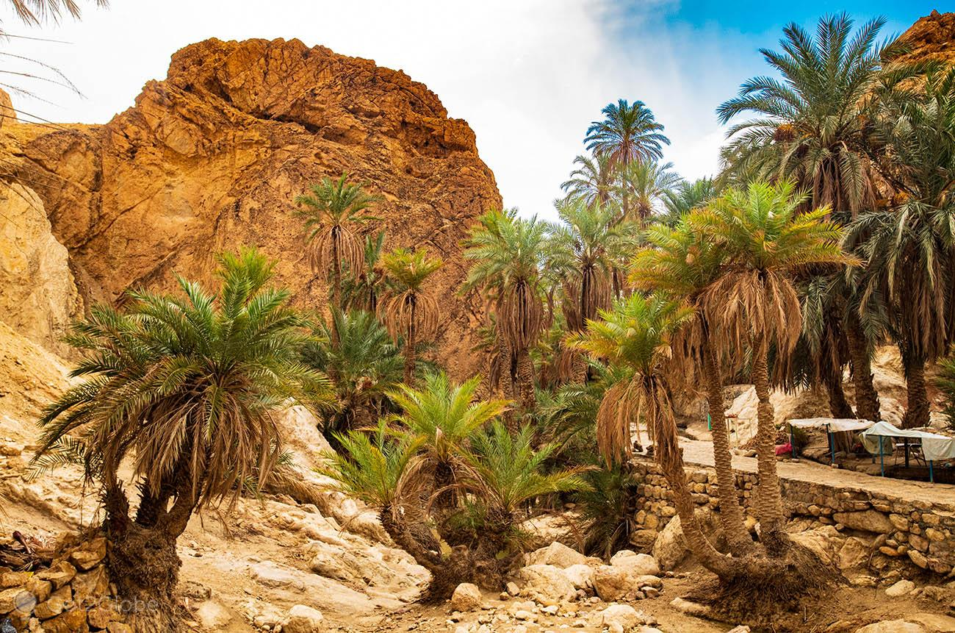
THE CANYONS OF MIDES : 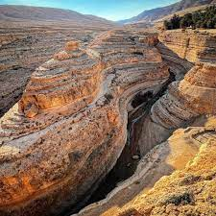

THE WATERFALLS OF TAMGHZA :
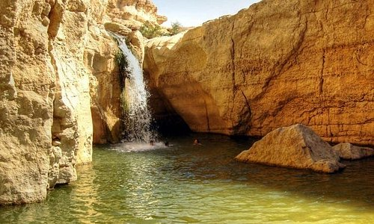
DECOR STAR WARS IN TOZEUR :
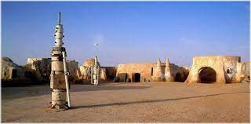
LA CORBEILLE DE NAFTA :
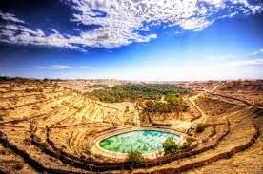
DINNER IN THE RESTAURANT DOUAR EL HAFSI :
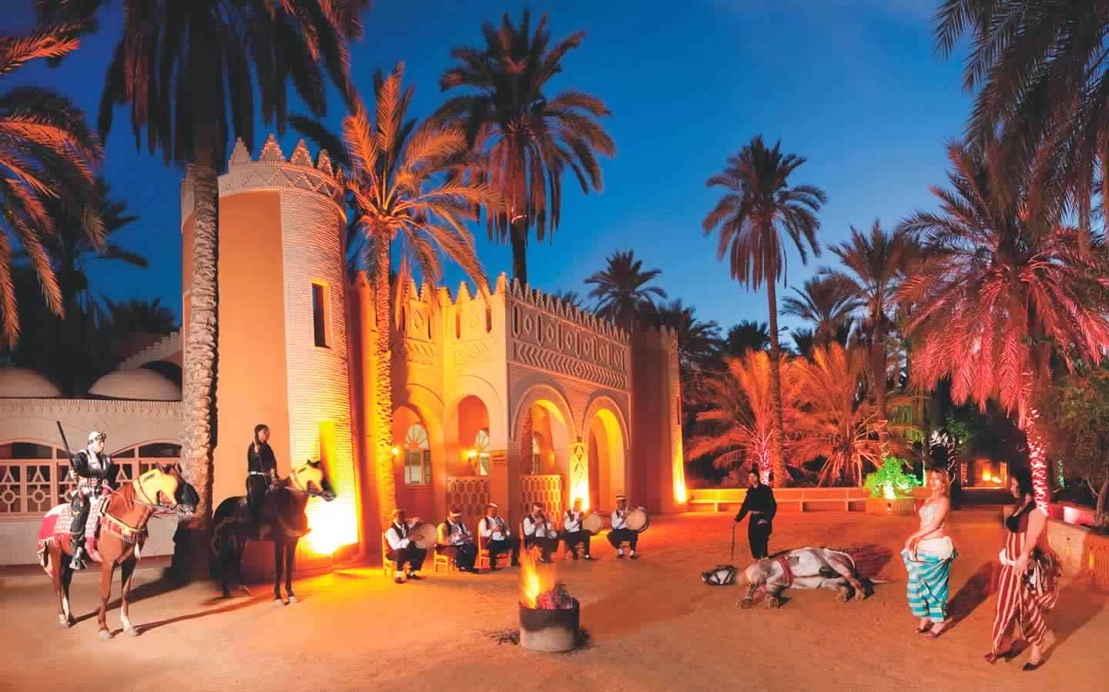
DAY 12 :
- Breakfast at the hotel
- Departure to Matmata
- Visit to the Star Wars decor: Hotel Sidi Idriss
- Lunch with locals: Berber cuisine
- Continue to Kairouan
- Accommodation in Kairouan: Dinner and night at the hotel

HOTEL SIDI IDRISS :
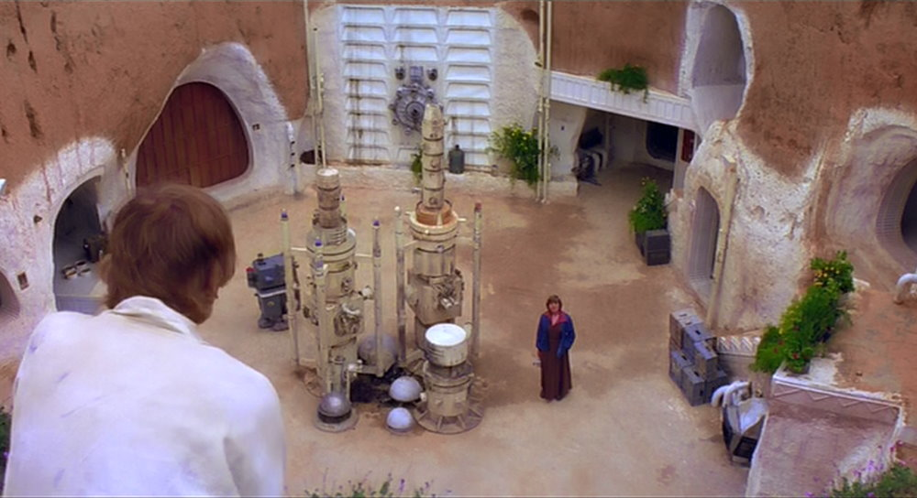
TROGLODYTE HOUSE :
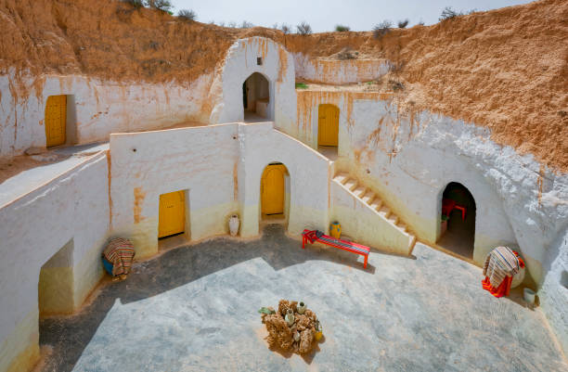
DAY 13 :
- Breakfast at the hotel
- Visit to Kairouan : world heritage 1998
- Treasure hunt in the Kairouan medina and collection of souvenirs
- Lunch in Kairouan
- Accommodation in Hammamet: Dinner and night at the hotel
- Dinner with party at the restaurant Shahrazade: the story “A Thousand and One Nights”

The Great Mosque of Kairouan, This emblematic mosque, considered one of the oldest and most important in North Africa, is a true architectural treasure. By visiting it, you will be amazed by its beauty and its history. You will admire the magnificent arches and columns, the detailed patterns and the splendid carpets which adorn the interior. Don't forget to take the time to reflect and appreciate the serenity that reigns in this sacred place.

THE GREAT MOSQUE KAIROUAN : 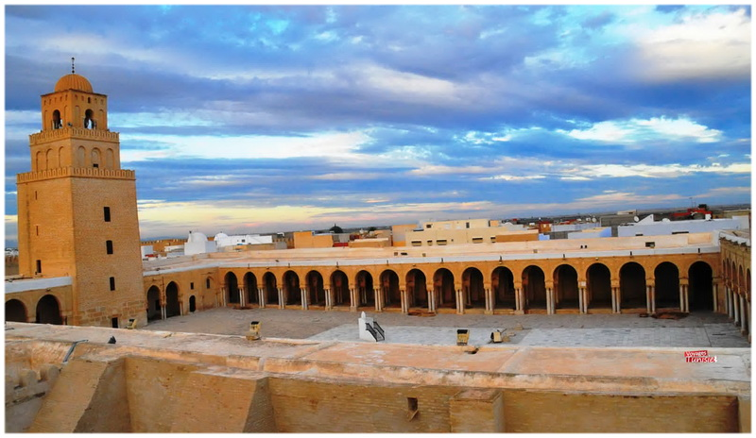

The treasure hunt in the Medina of Kairouan is a thrilling experience! This historic city, listed as a world heritage site since 1988, is full of secrets and history. During this treasure hunt, participants will have the opportunity to discover the treasures hidden in Kairouan while having fun. By solving puzzles and following clues, you will explore the narrow streets of the medina, visit historical monuments and discover iconic places. And best of all, participants earn unique souvenirs along the way and of course the big winner will have their reward.

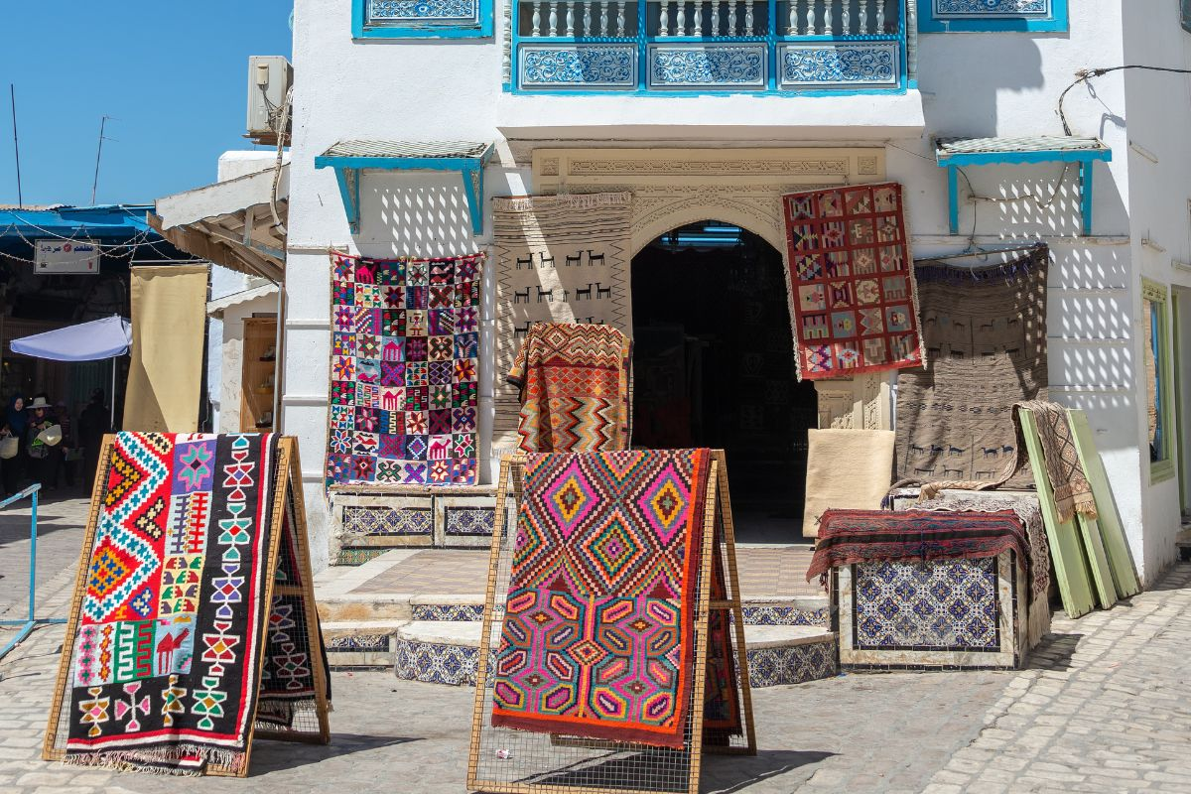
PARTY IN THE CHAHRAZED RESTAURANT:
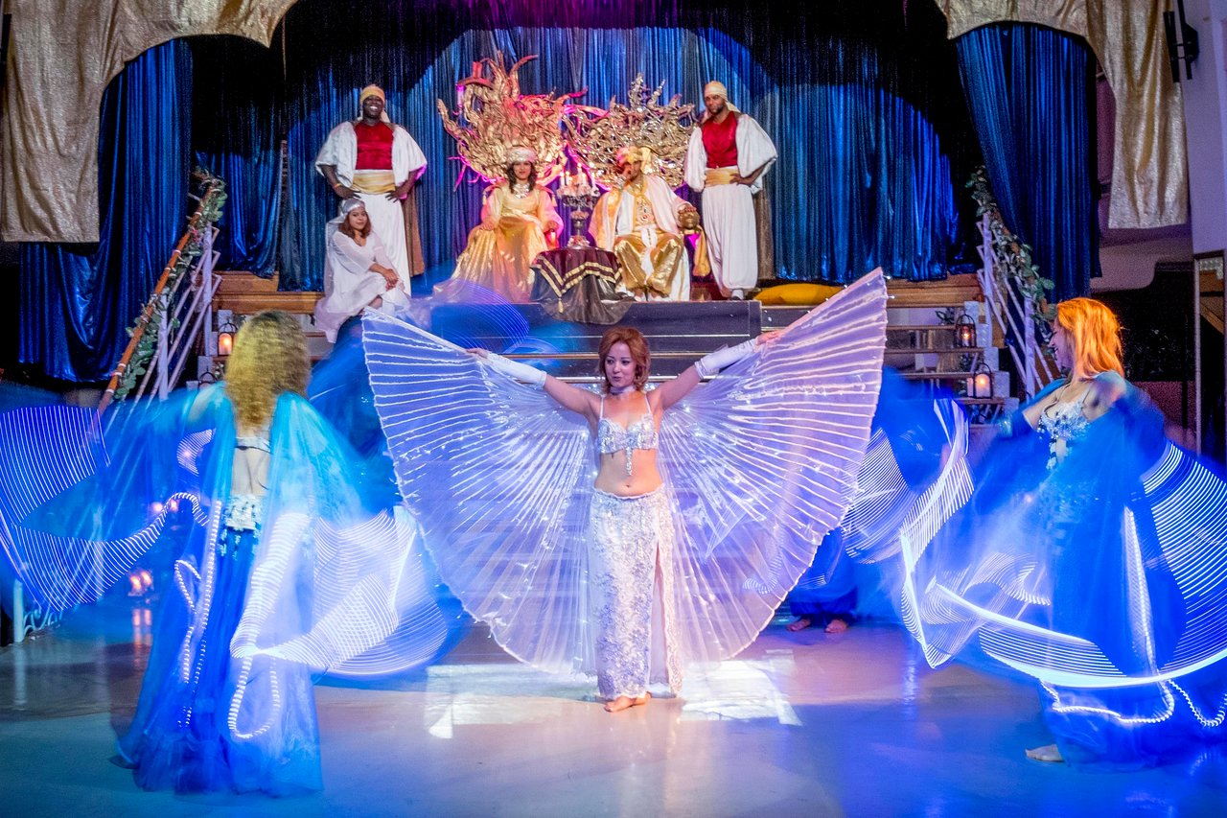

DAY 14 :

- Breakfast at the hotel
- Transfer from Hammamet to Tunis
- Assistance at Tunis Carthage airport
- End of our Services.

